EXPERIMENT III

AIM:
To identify and handle missing values, duplicate records, and outliers in the Health Insurance Lead Prediction dataset and perform data transformation techniques such as normalization, label encoding, and one-hot encoding using Python, Pandas, and Scikit-Learn.

ALGORITHM:
- Import the required Python libraries.
- Load the Health Insurance Lead Prediction dataset using Pandas.
- Display the first few records and check the dataset dimensions.
- Identify and count missing values in each column.
- Replace missing numerical values with the mean and categorical values with the mode.
- Detect and remove duplicate records from the dataset.
- Identify outliers in numerical columns using the Interquartile Range (IQR) method.
- Visualize the outliers using a box plot.
- Normalize selected numerical columns using Min-Max Scaling.
- Convert categorical variables into numerical format using Label Encoding.
- Apply One-Hot Encoding to categorical variables.
- Display the cleaned dataset, statistical summary, and save the processed dataset.

PROGRAM:
# ============================================================
# EXPERIMENT 3
# EXPLORATORY DATA ANALYSIS (EDA)
# DATA CLEANING AND DATA TRANSFORMATION
# Dataset: Health Insurance Lead Prediction Raw Data.csv
# ============================================================

# -----------------------------
# Import Libraries
# -----------------------------
import pandas as pd
import numpy as np
import matplotlib.pyplot as plt
from sklearn.preprocessing import MinMaxScaler, LabelEncoder

# -----------------------------
# Load Dataset
# -----------------------------
df = pd.read_csv("Health Insurance Lead Prediction Raw Data.csv")

print("="*80)
print("FIRST 5 ROWS")
print("="*80)
print(df.head())

print("\n" + "="*80)
print("LAST 5 ROWS")
print("="*80)
print(df.tail())

print("\nDataset Shape :", df.shape)

# ============================================================
# PROGRAM 1
# IDENTIFY MISSING VALUES
# ============================================================

print("\n" + "="*80)
print("MISSING VALUES")
print("="*80)

print(df.isnull())

# ============================================================
# PROGRAM 2
# COUNT MISSING VALUES
# ============================================================

print("\n" + "="*80)
print("COUNT OF MISSING VALUES")
print("="*80)

print(df.isnull().sum())

# ============================================================
# PROGRAM 3
# REPLACE MISSING VALUES
# ============================================================

print("\n" + "="*80)
print("REPLACING MISSING VALUES")
print("="*80)

# Numerical Columns
numeric_cols = df.select_dtypes(include=np.number).columns

# Categorical Columns
categorical_cols = df.select_dtypes(include="object").columns

# Fill Numerical Missing Values with Mean
for col in numeric_cols:
df[col] = df[col].fillna(df[col].mean())

# Fill Categorical Missing Values with Mode
for col in categorical_cols:
df[col] = df[col].fillna(df[col].mode()[0])

print("Missing Values After Filling\n")
print(df.isnull().sum())

# ============================================================
# PROGRAM 4
# REMOVE DUPLICATE RECORDS
# ============================================================

print("\n" + "="*80)
print("DUPLICATE RECORDS")
print("="*80)

duplicates = df.duplicated().sum()

print("Duplicate Rows Before Removal :", duplicates)

df.drop_duplicates(inplace=True)

print("Duplicate Rows After Removal :", df.duplicated().sum())

print("Dataset Shape :", df.shape)

# ============================================================
# PROGRAM 5
# DETECT OUTLIERS
# ============================================================

print("\n" + "="*80)
print("OUTLIER DETECTION")
print("="*80)

numeric_columns = df.select_dtypes(include=np.number).columns

for col in numeric_columns:

Q1 = df[col].quantile(0.25)
Q3 = df[col].quantile(0.75)

IQR = Q3 - Q1

lower = Q1 - 1.5 * IQR
upper = Q3 + 1.5 * IQR

outliers = df[(df[col] < lower) | (df[col] > upper)]

print(f"{col} : {len(outliers)} Outliers")

# -----------------------------
# Box Plot
# -----------------------------

plt.figure(figsize=(8,5))
plt.boxplot(df["Reco_Policy_Premium"])
plt.title("Box Plot of Reco Policy Premium")
plt.ylabel("Premium")
plt.grid(True)
plt.show()

# ============================================================
# PROGRAM 6
# NORMALIZATION
# ============================================================

print("\n" + "="*80)
print("MIN-MAX NORMALIZATION")
print("="*80)

scaler = MinMaxScaler()

columns_to_normalize = [
"Upper_Age",
"Lower_Age",
"Holding_Policy_Type",
"Reco_Policy_Premium"
]

df[columns_to_normalize] = scaler.fit_transform(df[columns_to_normalize])

print(df[columns_to_normalize].head())

# Histogram

plt.figure(figsize=(8,5))
plt.hist(df["Reco_Policy_Premium"], bins=30)
plt.title("Normalized Reco Policy Premium")
plt.xlabel("Premium")
plt.ylabel("Frequency")
plt.grid(True)
plt.show()

# ============================================================
# PROGRAM 7
# LABEL ENCODING
# ============================================================

print("\n" + "="*80)
print("LABEL ENCODING")
print("="*80)

label_columns = df.select_dtypes(include="object").columns

encoder = LabelEncoder()

for col in label_columns:
df[col] = encoder.fit_transform(df[col])

print(df.head())

# ============================================================
# PROGRAM 8
# ONE HOT ENCODING
# ============================================================

print("\n" + "="*80)
print("ONE HOT ENCODING")
print("="*80)

df_onehot = pd.get_dummies(
df,
columns=label_columns,
dtype=int
)

print(df_onehot.head())

# ============================================================
# FINAL DATASET
# ============================================================

print("\n" + "="*80)
print("FINAL CLEANED DATASET")
print("="*80)

print(df.head())

# ============================================================
# DATASET INFORMATION
# ============================================================

print("\n" + "="*80)
print("DATASET INFORMATION")
print("="*80)

print(df.info())

# ============================================================
# STATISTICAL SUMMARY
# ============================================================

print("\n" + "="*80)
print("STATISTICAL SUMMARY")
print("="*80)

print(df.describe())

# ============================================================
# SAVE CLEANED DATASET
# ============================================================

df.to_csv("Health_Insurance_Cleaned.csv", index=False)

print("\nCleaned dataset saved successfully as 'Health_Insurance_Cleaned.csv'")

OUTPUT:
================================================================================
FIRST 5 ROWS
================================================================================
ID City_Code Region_Code Accomodation_Type Reco_Insurance_Type Upper_Age \
0 1 C3 3213 Rented Individual 36
1 2 C5 1117 Owned Joint 75
2 3 C5 3732 Owned Individual 32
3 4 C24 4378 Owned Joint 52
4 5 C8 2190 Rented Individual 44

Lower_Age Is_Spouse Health Indicator Holding_Policy_Duration \
0 36 No X1 14+
1 22 No X2 NaN
2 32 No NaN 1.0
3 48 No X1 14+
4 44 No X2 3.0

Holding_Policy_Type Reco_Policy_Cat Reco_Policy_Premium Response
0 3.0 22 11628.0 0
1 NaN 22 30510.0 0
2 1.0 19 7450.0 1
3 3.0 19 17780.0 0
4 1.0 16 10404.0 0

================================================================================
LAST 5 ROWS
================================================================================
ID City_Code Region_Code Accomodation_Type Reco_Insurance_Type \
50877 50878 C4 845 Rented Individual
50878 50879 C5 4188 Rented Individual
50879 50880 C1 442 Rented Individual
50880 50881 C1 4 Owned Joint
50881 50882 C3 3866 Rented Individual

Upper_Age Lower_Age Is_Spouse Health Indicator \
50877 22 22 No X3
50878 27 27 No X3
50879 63 63 No X2
50880 71 49 No X2
50881 24 24 No X3

Holding_Policy_Duration Holding_Policy_Type Reco_Policy_Cat \
50877 NaN NaN 18
50878 7.0 3.0 4
50879 14+ 1.0 12
50880 2.0 2.0 16
50881 2.0 3.0 18

Reco_Policy_Premium Response
50877 7704.0 0
50878 5408.0 0
50879 11374.0 0
50880 28179.2 1
50881 11424.0 0

Dataset Shape : (50882, 14)

================================================================================
MISSING VALUES
================================================================================
ID City_Code Region_Code Accomodation_Type Reco_Insurance_Type \
0 False False False False False
1 False False False False False
2 False False False False False
3 False False False False False
4 False False False False False
... ... ... ... ... ...
50877 False False False False False
50878 False False False False False
50879 False False False False False
50880 False False False False False
50881 False False False False False

Upper_Age Lower_Age Is_Spouse Health Indicator \
0 False False False False
1 False False False False
2 False False False True
3 False False False False
4 False False False False
... ... ... ... ...
50877 False False False False
50878 False False False False
50879 False False False False
50880 False False False False
50881 False False False False

Holding_Policy_Duration Holding_Policy_Type Reco_Policy_Cat \
0 False False False
1 True True False
2 False False False
3 False False False
4 False False False
... ... ... ...
50877 True True False
50878 False False False
50879 False False False
50880 False False False
50881 False False False

Reco_Policy_Premium Response
0 False False
1 False False
2 False False
3 False False
4 False False
... ... ...
50877 False False
50878 False False
50879 False False
50880 False False
50881 False False

[50882 rows x 14 columns]

================================================================================
COUNT OF MISSING VALUES
================================================================================
ID 0
City_Code 0
Region_Code 0
Accomodation_Type 0
Reco_Insurance_Type 0
Upper_Age 0
Lower_Age 0
Is_Spouse 0
Health Indicator 11691
Holding_Policy_Duration 20251
Holding_Policy_Type 20251
Reco_Policy_Cat 0
Reco_Policy_Premium 0
Response 0
dtype: int64

================================================================================
REPLACING MISSING VALUES
================================================================================
Missing Values After Filling

ID 0
City_Code 0
Region_Code 0
Accomodation_Type 0
Reco_Insurance_Type 0
Upper_Age 0
Lower_Age 0
Is_Spouse 0
Health Indicator 0
Holding_Policy_Duration 0
Holding_Policy_Type 0
Reco_Policy_Cat 0
Reco_Policy_Premium 0
Response 0
dtype: int64

================================================================================
DUPLICATE RECORDS
================================================================================
Duplicate Rows Before Removal : 0
Duplicate Rows After Removal : 0
Dataset Shape : (50882, 14)

================================================================================
OUTLIER DETECTION
================================================================================
ID : 0 Outliers
Region_Code : 201 Outliers
Upper_Age : 0 Outliers
Lower_Age : 0 Outliers
Holding_Policy_Type : 0 Outliers
Reco_Policy_Cat : 0 Outliers
Reco_Policy_Premium : 821 Outliers
Response : 12209 Outliers
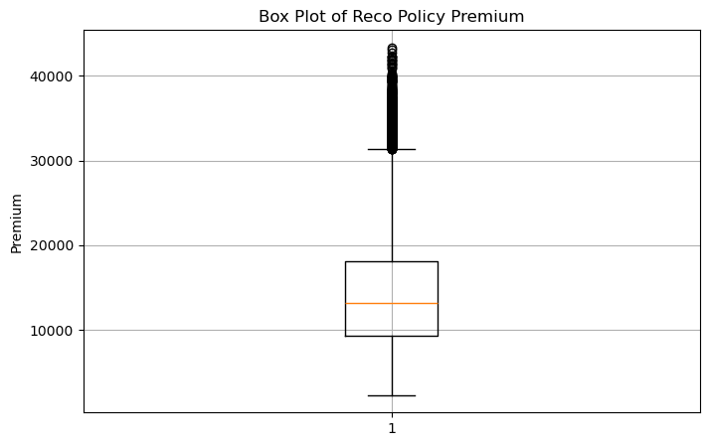

================================================================================
MIN-MAX NORMALIZATION
================================================================================
Upper_Age Lower_Age Holding_Policy_Type Reco_Policy_Premium
0 0.315789 0.338983 0.666667 0.227609
1 1.000000 0.101695 0.479743 0.687356
2 0.245614 0.271186 0.000000 0.125881
3 0.596491 0.542373 0.666667 0.377401
4 0.456140 0.474576 0.000000 0.197807

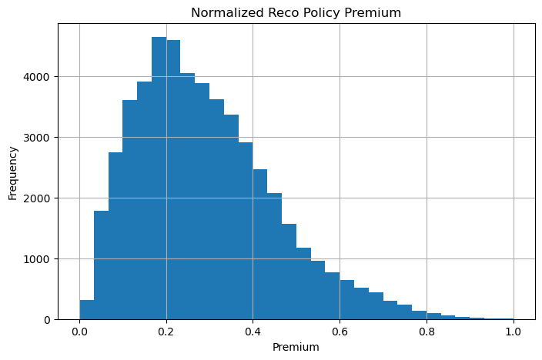

================================================================================
LABEL ENCODING
================================================================================
ID City_Code Region_Code Accomodation_Type Reco_Insurance_Type \
0 1 22 3213 1 0
1 2 31 1117 0 1
2 3 31 3732 0 0
3 4 16 4378 0 1
4 5 34 2190 1 0

Upper_Age Lower_Age Is_Spouse Health Indicator Holding_Policy_Duration \
0 0.315789 0.338983 0 0 5
1 1.000000 0.101695 0 1 0
2 0.245614 0.271186 0 0 0
3 0.596491 0.542373 0 0 5
4 0.456140 0.474576 0 1 8

Holding_Policy_Type Reco_Policy_Cat Reco_Policy_Premium Response
0 0.666667 22 0.227609 0
1 0.479743 22 0.687356 0
2 0.000000 19 0.125881 1
3 0.666667 19 0.377401 0
4 0.000000 16 0.197807 0

================================================================================
ONE HOT ENCODING
================================================================================
ID Region_Code Upper_Age Lower_Age Holding_Policy_Type \
0 1 3213 0.315789 0.338983 0.666667
1 2 1117 1.000000 0.101695 0.479743
2 3 3732 0.245614 0.271186 0.000000
3 4 4378 0.596491 0.542373 0.666667
4 5 2190 0.456140 0.474576 0.000000

Reco_Policy_Cat Reco_Policy_Premium Response City_Code_0 City_Code_1 \
0 22 0.227609 0 0 0
1 22 0.687356 0 0 0
2 19 0.125881 1 0 0
3 19 0.377401 0 0 0
4 16 0.197807 0 0 0

... Holding_Policy_Duration_5 Holding_Policy_Duration_6 \
0 ... 1 0
1 ... 0 0
2 ... 0 0
3 ... 1 0
4 ... 0 0

Holding_Policy_Duration_7 Holding_Policy_Duration_8 \
0 0 0
1 0 0
2 0 0
3 0 0
4 0 1

Holding_Policy_Duration_9 Holding_Policy_Duration_10 \
0 0 0
1 0 0
2 0 0
3 0 0
4 0 0

Holding_Policy_Duration_11 Holding_Policy_Duration_12 \
0 0 0
1 0 0
2 0 0
3 0 0
4 0 0

Holding_Policy_Duration_13 Holding_Policy_Duration_14
0 0 0
1 0 0
2 0 0
3 0 0
4 0 0

[5 rows x 74 columns]

================================================================================
FINAL CLEANED DATASET
================================================================================
ID City_Code Region_Code Accomodation_Type Reco_Insurance_Type \
0 1 22 3213 1 0
1 2 31 1117 0 1
2 3 31 3732 0 0
3 4 16 4378 0 1
4 5 34 2190 1 0

Upper_Age Lower_Age Is_Spouse Health Indicator Holding_Policy_Duration \
0 0.315789 0.338983 0 0 5
1 1.000000 0.101695 0 1 0
2 0.245614 0.271186 0 0 0
3 0.596491 0.542373 0 0 5
4 0.456140 0.474576 0 1 8

Holding_Policy_Type Reco_Policy_Cat Reco_Policy_Premium Response
0 0.666667 22 0.227609 0
1 0.479743 22 0.687356 0
2 0.000000 19 0.125881 1
3 0.666667 19 0.377401 0
4 0.000000 16 0.197807 0

================================================================================
DATASET INFORMATION
================================================================================
<class 'pandas.core.frame.DataFrame'>
RangeIndex: 50882 entries, 0 to 50881
Data columns (total 14 columns):
# Column Non-Null Count Dtype
--- ------ -------------- -----
0 ID 50882 non-null int64
1 City_Code 50882 non-null int64
2 Region_Code 50882 non-null int64
3 Accomodation_Type 50882 non-null int64
4 Reco_Insurance_Type 50882 non-null int64
5 Upper_Age 50882 non-null float64
6 Lower_Age 50882 non-null float64
7 Is_Spouse 50882 non-null int64
8 Health Indicator 50882 non-null int64
9 Holding_Policy_Duration 50882 non-null int64
10 Holding_Policy_Type 50882 non-null float64
11 Reco_Policy_Cat 50882 non-null int64
12 Reco_Policy_Premium 50882 non-null float64
13 Response 50882 non-null int64
dtypes: float64(4), int64(10)
memory usage: 5.4 MB
None

================================================================================
STATISTICAL SUMMARY
================================================================================
ID City_Code Region_Code Accomodation_Type \
count 50882.000000 50882.000000 50882.000000 50882.000000
mean 25441.500000 14.974981 1732.788707 0.450670
std 14688.512535 12.147432 1424.081652 0.497566
min 1.000000 0.000000 1.000000 0.000000
25% 12721.250000 4.000000 523.000000 0.000000
50% 25441.500000 11.000000 1391.000000 0.000000
75% 38161.750000 30.000000 2667.000000 1.000000
max 50882.000000 35.000000 6194.000000 1.000000

Reco_Insurance_Type Upper_Age Lower_Age Is_Spouse \
count 50882.000000 50882.000000 50882.000000 50882.000000
mean 0.203333 0.471163 0.453201 0.165520
std 0.402482 0.303689 0.293549 0.371653
min 0.000000 0.000000 0.000000 0.000000
25% 0.000000 0.175439 0.186441 0.000000
50% 0.000000 0.456140 0.406780 0.000000
75% 0.000000 0.719298 0.694915 0.000000
max 1.000000 1.000000 1.000000 1.000000

Health Indicator Holding_Policy_Duration Holding_Policy_Type \
count 50882.000000 50882.000000 50882.000000
mean 1.112751 4.133171 0.479743
std 1.406159 4.601652 0.265332
min 0.000000 0.000000 0.000000
25% 0.000000 0.000000 0.333333
50% 1.000000 1.000000 0.479743
75% 2.000000 8.000000 0.666667
max 8.000000 14.000000 1.000000

Reco_Policy_Cat Reco_Policy_Premium Response
count 50882.000000 50882.000000 50882.000000
mean 15.115188 0.289843 0.239947
std 6.340663 0.160458 0.427055
min 1.000000 0.000000 0.000000
25% 12.000000 0.169660 0.000000
50% 17.000000 0.265349 0.000000
75% 20.000000 0.385095 0.000000
max 22.000000 1.000000 1.000000

Cleaned dataset saved successfully as 'Health_Insurance_Cleaned.csv'

